Sustainable CO Production via Solar Thermochemical CO₂ Splitting in a Cerium Oxide Reactor
Paula Rojas A.¹, Maximiliano Quezada E.¹, Mario Toledo T.¹
¹Department of Mechanical Engineering, Universidad Técnica Federico Santa María, Valparaíso, Chile.

Abstract
Global warming, driven mainly by CO₂ emissions from fossil fuel use, motivates the development of renewable syngas (H₂/CO) as a feedstock for synthetic fuels (e-fuels), enabling renewable energy to be stored in chemical form. Chile has privileged solar radiation conditions for the production of this energy vector. In this work, a cerium oxide solar reactor, previously validated for H₂ production via water-splitting, is experimentally evaluated for CO generation from CO₂ through two-step thermochemical redox cycles (reduction and oxidation). The system operates hybridly using electrical/photovoltaic heating and solar concentration, incorporating a gas supply and analysis system (Testo 350 analyzer) and a 1D numerical model solved using the TDMA method. Two configurations were studied, varying the duration of the oxidation step (40 and 20 min). The results confirm sustainable CO production, reaching conversion efficiencies of 2.4–3.3%, higher than those obtained in water-splitting mode (0.65%) under the same operating conditions, although lower than values reported in the literature (5.25%). The study provides relevant experimental evidence for the development of a solar syngas industry in Chile.

Keywords: | Syngas, Solar energy, CO₂-splitting, Thermochemical cycles, Cerium oxide
Thematic area: | ☐ Electrical infrastructure ☐ Technological integration and artificial intelligence ☐ Materials and manufacturing
Thematic area: | ☐ Chemical and biochemical processes ☒ Thermal processes and combustion ☐ Other area:
TRL level: | ☐ TRL 1 ☐ TRL 2 ☐ TRL 3 ☐ TRL 4 ☒ TRL 5 ☐ TRL 6 ☐ TRL 7 ☐ TRL 8 ☐ TRL 9 ☐ N/A

Introduction
Global warming, a phenomenon driven mainly by greenhouse gas emissions from fossil fuel use, calls for decarbonization alternatives for hard-to-electrify sectors. Renewable syngas, composed of H₂ and CO, is the fundamental feedstock for e-fuel production, enabling renewable energy to be stored in chemical form and reducing net CO₂ emissions [1]. Chile has privileged conditions for its production from renewable resources, thanks to the high solar radiation in the north of the country and the wind resources in the south, and already has the first public policy guidelines through the Green Hydrogen Action Plan [2]. The objective of this work is to carry out experimental tests on a cerium-oxide-based solar reactor for sustainable CO production from CO₂, evaluating the feasibility of generating syngas through two-step thermochemical cycles (reduction and oxidation) with metal oxides in a porous medium format. The system had previously been validated for H₂ production and offers the advantage of hybrid operation using concentrated solar energy and photovoltaic energy, a feature especially attractive for northern Chile due to its abundant solar resource [3].
Methodology
A cerium oxide solar reactor was implemented together with its auxiliary systems: (i) a heating system using electrical resistances powered by photovoltaic panels and a solar concentrator; (ii) a gas supply system (N₂ and CO₂) using pressurized cylinders and flow controllers; (iii) a gas treatment and analysis system, comprising a bubbler, a water/silica trap, a vacuum pump, and a Testo 350 analyzer; and (iv) a temperature monitoring system using type B thermocouples installed radially in the reactor. During the reduction step, at temperatures above 800 °C, a power close to 3000 W was used, and N₂ was employed as a sweep gas to remove the oxygen released by the redox material. In the oxidation step, the power was reduced by half (1500 W), operating below 800 °C, using CO₂ as the oxidizing and sweep gas, yielding CO and CO₂ at the outlet. Two experimental cases were evaluated (in triplicate), maintaining N₂ and CO₂ flow rates of 6 L/min and a 40-min reduction step, varying only the duration of the oxidation step: 40 min (Case 1) and 20 min (Case 2). In addition, a 1D mathematical model representing the reactor's reduction and oxidation steps was used. The governing equations were discretized using an implicit scheme and solved with the TDMA (TriDiagonal Matrix Algorithm) method, implemented in Fortran. The model, experimentally validated, allows optimal operating conditions to be identified considering the inlet gas velocity, the power supplied during the reduction step, and the duration of each stage of the cycle.
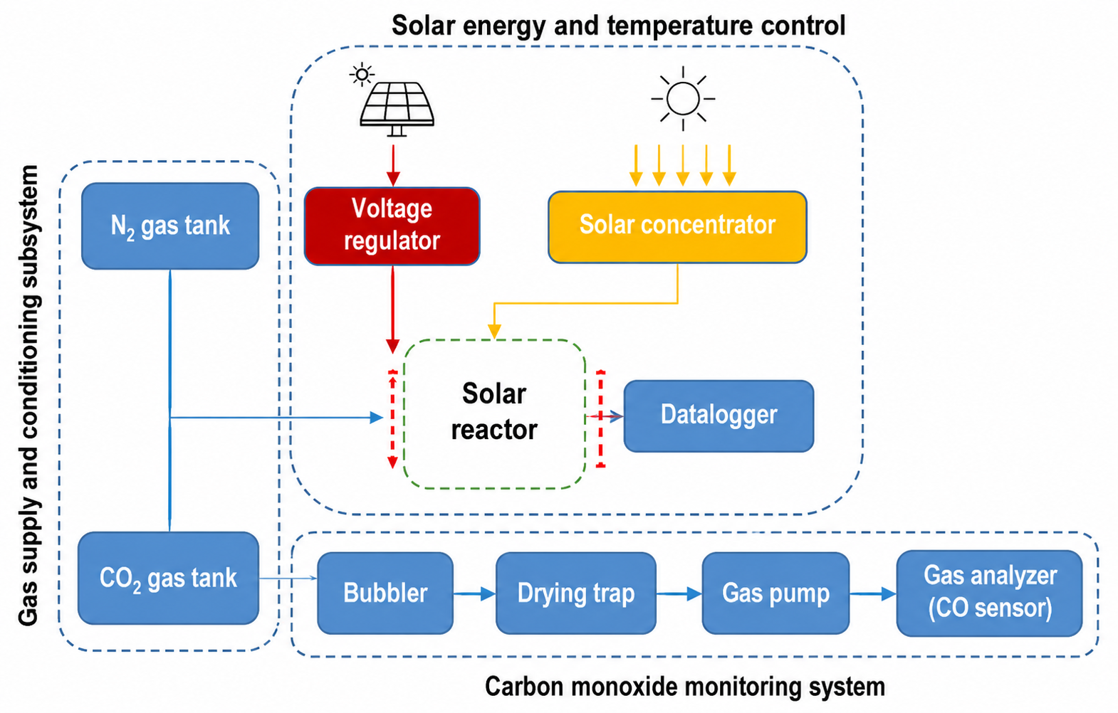
Figure 1. Schematic of the experimental setup. Own elaboration.
Results
The standard temperature profile of the tests was obtained (heating from room temperature to ~800 °C during reduction, followed by the oxidation step), along with the temperature and gas concentration profiles (CO, O₂, CO₂) for both cases, based on three repetitions per case. The results show: (i) validation of CO production using the solar reactor; (ii) higher efficiency for Case 1 (40-min oxidation) compared to Case 2 (20 min); (iii) operating conditions similar to those of the previously reported water-splitting case; and (iv) an appreciable difference in the reaction rate during the oxidation step between the two cases. A comparison with results from Marxer [4] shows that the reduction temperature achieved and the efficiency are lower.

Table 1. Comparison of water-splitting and CO₂-splitting results (Cases 1–2).
Parameter | Water-splitting | CO₂-splitting
T_{red,max} [°C] | 830 | 830
Duration_{ox} [min] | 40 | 40 – 20
η_{conversion} | 0.65% | 3.3% – 2.4%
η_{energy} | 0.05% | 0.3% – 0.3%
Conclusions
The sustainable production of CO is experimentally verified using the cerium oxide solar reactor, previously validated for H₂, confirming its feasibility as a hybrid platform for solar-based syngas generation. A possible overlap between the reduction and oxidation reactions associated with the operating temperature is identified, opening a line of work to optimize the separation of the steps. Future work includes: (i) strengthening the gas outlet system to minimize pressure losses; (ii) complementing the 1D model with CO generation and scaling it up to a 2D model for parametrization testing; and (iii) varying the operating power and the duration of the oxidation step to identify the point of maximum efficiency. These results represent a contribution to the development of a solar synthetic fuels industry in Chile, leveraging its privileged solar resource in the north of the country.
Acknowledgments
The authors thank ANID-Chile (Project VIU23P0116) for its financial support in carrying out this work.
Conflicts of interest
The authors declare no conflicts of interest.
References
- Warren, K., et al. (2022). Solar thermochemical fuels: Present status and future prospects. Solar Compass 1, 1, 100010.
- Ministry of Energy. (2020). National Green Hydrogen Strategy. Government of Chile.
- Rojas, P., et al. (2025). Numerical and experimental investigation of a two-stage thermochemical water-splitting reactor based on a cerium oxide reduction-oxidation cycle. ECM 323, 1192217 (2025).
- Marxer, D., et al. (2017). Solar thermochemical splitting of CO₂ into separate streams of CO and O₂ with high selectivity, stability, conversion, and efficiency. EES, 10, 1142.

